**Physics 12 practice – sheet 2**

1. Which of the following is a vector quantity?

A. work

B. electric field

C. potential energy

D. potential difference

2. An aircraft is flying due south. Some time later it is flying due east. Which vector best represents the aircraft’s change in velocity?

A. B. C. D.

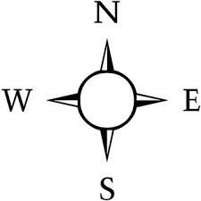

3. A projectile is launched horizontally from a cliff edge as shown.

**15 m/s**

**25 m**

What is the projectile’s time of flight?

A. 1.2 s

B. 1.7 s

C. 2.3 s

D. 2.7 s

4. A 5.0 kg block is on an incline. The friction force acting on the block is 25 N.

**F**

What is the magnitude of the force, F, parallel to the incline, needed to move the block up the slope at constant speed?

A. 14 N

B. 25 N

C. 52 N

D. 74 N

5. A varying force applied to an object is described by the force vs. distance graph below.



What is the work done by this force as it moves the object from 0.40 to 0.60 m?

A. 0.80 J

B. 2.0 J

C. 3.2 J

D. 20 J

6. A 25 kg block is shown suspended by two ropes. What is the tension in rope 2?



A. 110 N

B. 120 N

C. 260 N

D. 430 N

KEY:

1. B
2. A
3. C
4. C
5. B
6. A